RETAIL REVENUE & BUSINESS PERFORMANCE ANALYSIS DASHBOARD

MONISRI L
E25FA028
B.COM FINTECH AND AI

1. Project Overview
For this project, I designed a Retail Revenue and Business Performance Dashboard using Microsoft Power BI. The dashboard is developed with sales-related information covering products, customers, stores, employees, orders and locations.
The main purpose of this project is to understand how a retail business performs in terms of revenue, profit, product sales and store activities. Instead of studying large amounts of raw data, I presented the information through interactive charts, tables and KPI cards.
The report allows users to examine sales performance across different product categories, compare stores and cities, and observe revenue changes over different months and years.
I also included interactive filters and advanced dashboard options to make the analysis easier and more useful.
2. Project Objectives
The following objectives were considered while developing this dashboard:
- To measure the overall revenue and profit of the retail business.
- To examine the total quantity of products sold.
- To understand the number of orders received.
- To compare the financial contribution of product categories.
- To study the revenue performance of individual stores.
- To examine sales across different cities and states.
- To understand revenue changes during different months and years.
- To compare business performance across store types.
- To analyse sales based on customer segments.
- To develop an interactive report for better business analysis.

3. Dataset Information
I used a dataset containing nine tables to prepare the retail performance report.
The tables included in the project are:
- Dim City
- Dim Customer
- Dim Date
- Dim Order
- Dim Product
- Dim Salesperson
- Dim State
- Dim Store
- Fact Sales
The dataset provides information about sales transactions, customer details, product categories, store locations, order details and salesperson information.
These tables helped me connect different business details and analyse the performance of the retail business from multiple perspectives.
4. Data Cleaning and Transformation
I used Power Query Editor to prepare the imported CSV files before creating the dashboard.
The following data preparation activities were performed:
- Organised the imported tables by giving them proper names.
- Converted ID columns into Whole Number format.
- Changed financial columns such as price, revenue, cost and profit into Decimal Number format.
- Set product, customer and category names as Text values.
- Corrected the date and date-time column formats.
- Changed text-based status fields into True/False data types.
- Checked the columns and corrected data format errors.
- Applied all the changes using Close & Apply.
These steps helped maintain a proper data structure and made the information ready for calculations and visual presentation.
5. Data Modelling and Table Connections
After preparing the dataset, I connected the Fact Sales table with the related dimension tables through Model View.
I created eight relationships between the tables:
- Fact Sales and Dim Product using product_id.
- Fact Sales and Dim Customer using customer_id.
- Fact Sales and Dim Store using store_id.
- Fact Sales and Dim Salesperson using salesperson_id.
- Fact Sales and Dim Date using date_id.
- Fact Sales and Dim Order using order_id.
- Dim City and Dim State using state_id.
- Dim Store and Dim City using city_id.
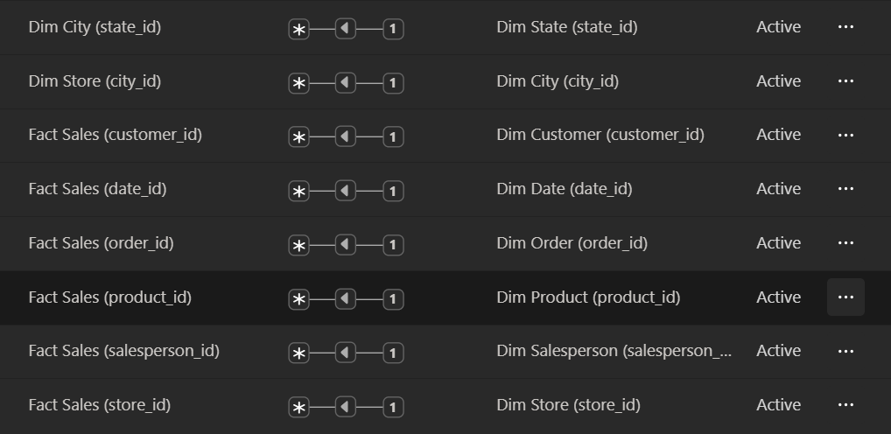
All eight relationships were configured with Many-to-One (*:1) cardinality, Single cross-filter direction and Active status.
These connections allow Power BI to combine information from different tables and display the correct results when filters are selected.
6. DAX Calculations
I created eight DAX measures to calculate the important values required for the dashboard.
The measures and their purposes are given below.
Measure | Calculation / Purpose
Total Quantity | SUM('Fact Sales'[quantity]) – Calculates the total units sold.
Total Revenue | SUM('Fact Sales'[total_amount]) – Finds the total sales income.
Total Cost | SUM('Fact Sales'[cost_amount]) – Calculates the total product cost.
Total Profit | SUM('Fact Sales'[profit_amount]) – Finds the overall profit.
Average Unit Price | AVERAGE('Fact Sales'[unit_price]) – Calculates the average selling price per unit.
Total Transactions | COUNT('Fact Sales'[sales_id]) – Counts the sales records.
Total Orders | DISTINCTCOUNT('Fact Sales'[order_id]) – Counts unique orders.
Average Order Value | DIVIDE([Total Revenue], [Total Orders]) – Finds the average revenue per order.
I formatted the financial measures using Indian Rupee (₹) currency formatting and displayed quantity, transaction and order counts as whole numbers.
These calculations provide the numerical information used in the dashboard.
7. Dashboard Design and Visual Analysis
I created a main report page named Retail Sales Dashboard. It contains KPI cards, charts, a store performance table and different filters.
7.1 Main Performance Indicators
I designed four KPI cards to display the important business results.
The cards represent:
- Total Revenue
- Total Profit
- Total Quantity
- Total Orders
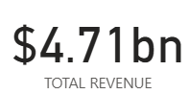 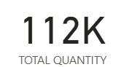 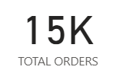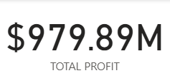
These indicators provide a quick understanding of the business performance without having to examine every chart separately.
7.2 Category-wise Revenue Comparison
I used a Clustered Column Chart to display the revenue earned from different product categories.
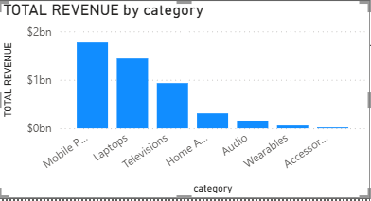
- X-axis: Product Category
- Y-axis: Total Revenue
This chart helps compare the sales contribution of different categories and understand which products generate more revenue.
7.3 Profit Contribution by Products
I selected a Treemap to represent the profit earned from each product category.
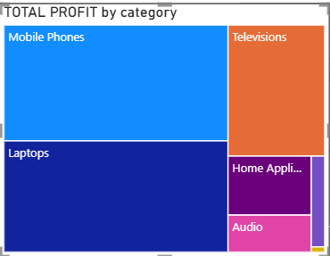
- Category: Product Category
- Values: Total Profit
Each section of the treemap represents a product category. The size of the section changes according to its profit contribution.
This visual makes it easier to compare profit across categories.
7.4 Store-wise Revenue Comparison
I created a Clustered Bar Chart to display revenue earned by individual stores.
- Y-axis: Store Name
- X-axis: Total Revenue
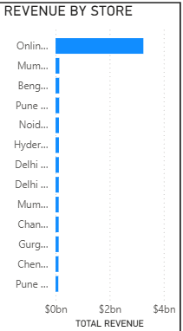
This chart helps compare the financial performance of different stores and identify stores generating higher revenue.
7.5 Monthly and Yearly Revenue Analysis
I used a Line Chart to display revenue changes across months and years.
- X-axis: Year and Month
- Y-axis: Total Revenue
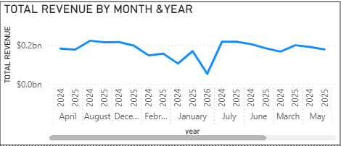
This chart helps observe the movement of revenue over time and compare performance between different periods.
7.6 Revenue by Store Category
I created a Doughnut Chart to show how revenue is shared among different store types.
- Legend: Store Type
- Values: Total Revenue
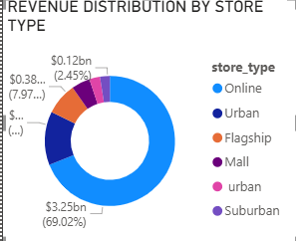
This chart helps compare the revenue contribution of online and physical store categories.
7.7 City-level Revenue Analysis
I used another Clustered Bar Chart to compare revenue generated across different cities.
- Y-axis: City Name
- X-axis: Total Revenue
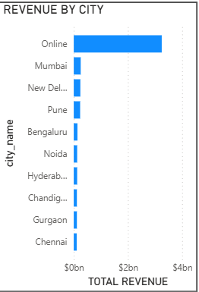
I excluded the Online category from this visual to concentrate on the performance of individual cities.
This makes it easier to compare sales across different geographical locations.
8. Interactive Filters
I added five slicers to allow users to view selected business information.
The slicers used in the dashboard are:
1. Year: Helps display sales details for the selected year.
2. Store Type: Allows comparison between different store categories.
3. Customer Segment: Helps examine sales based on customer groups.
4. State: Filters the report according to the selected state.
5. Product Category: Displays information related to selected product categories.
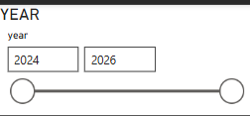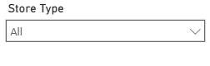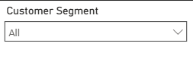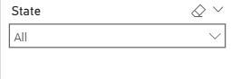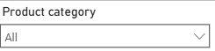
These filters make it possible to study the dashboard from different angles. When a user selects a filter, the connected visuals update according to the selection.
9. Additional Dashboard Features
I included several advanced features to provide more detailed information and improve the dashboard experience.
9.1 Product Category Drill-Down
I added a drill-down option to the category revenue chart.
This feature allows users to move from a main product category to its smaller subcategories.
It helps examine revenue at different product levels without creating separate charts for every category.
9.2 Year and Month Drill-Down
I included a drill-down option in the Monthly Revenue Trend chart.
Users can select a particular year and explore the revenue generated during individual months.
This helps to examine sales performance at both yearly and monthly levels.
9.3 Store Performance Table
I created a table to present the financial results of individual stores.
The table contains:
- Store Name
- Total Revenue
- Total Profit
- Revenue Sparkline
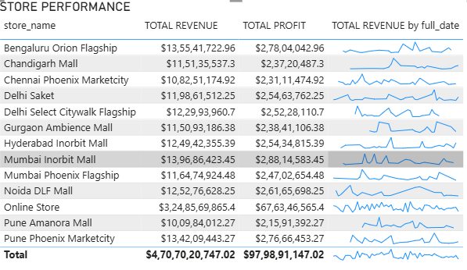
I arranged the table in descending order of revenue so that higher-revenue stores appear first.
This makes store comparisons easier.
9.4 Conditional Formatting
I applied Data Bars to the Total Revenue column in the store performance table.
The bars provide a visual comparison of revenue values across different stores.
This feature helps users quickly understand which stores have higher or lower revenue.

9.5 Revenue Sparklines
I added Sparklines to show the revenue movement of individual stores over time.
These small trend charts are displayed within the store performance table.
They help users compare store performance and observe revenue changes without opening a separate chart.
9.6 Store Type Tooltip
I created a separate report page named Store Type Tooltip.
The page contains four important financial measures:
- Total Revenue
- Total Profit
- Total Orders
- Average Order Value
I connected this tooltip page to the Store Type Doughnut Chart.
When users move the cursor over a store type, the tooltip displays additional financial information related to that selection.
This provides more details while keeping the main dashboard organised.
10. Business Analysis and Observations
Using the dashboard, I was able to study several important areas of retail business performance.
The major observations include:
- Overall business revenue and profit can be understood through KPI cards.
- The total quantity sold provides information about product sales volume.
- Total orders help measure order activity.
- Product category charts help compare revenue and profit contributions.
- Store-wise analysis helps compare the performance of different outlets.
- City-wise revenue analysis provides information about geographical sales distribution.
- Monthly and yearly charts help examine revenue movement over time.
- Store type analysis helps compare online and physical store performance.
- Customer segment filters help explore different customer groups.
- Sparklines provide a quick view of revenue trends for individual stores.
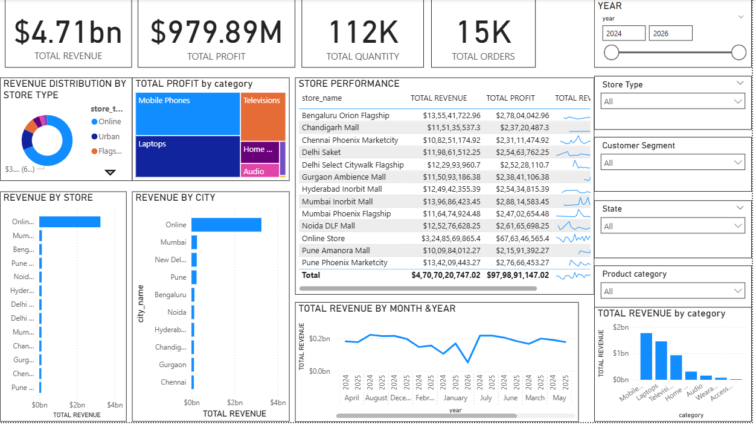
These analyses help understand the business performance and identify areas that may require further attention.
11. Conclusion
Through this project, I gained practical knowledge of using Microsoft Power BI for retail business analysis.
I learned how to prepare raw data using Power Query, create relationships between multiple tables and develop DAX measures for calculating important financial values.
I also explored different visualisation techniques, including KPI cards, column charts, bar charts, treemaps, doughnut charts and line charts.
The use of slicers, drill-down, sparklines, tooltips and conditional formatting helped me create a more informative and interactive dashboard.
Overall, this project improved my understanding of business performance analysis, data modelling and financial data visualisation. It also helped me learn how Power BI can convert sales information into useful insights for business planning and decision-making.

